Dear Collaborate,

We are glad to inform you that the following students from your University applied to our BIP Summer School:

In order to complete the process it is necessary that we receive their:
- Student Application Form
- Learning Agreement
- CV-EU pass form preferable
- Certificate for English language proficiency

Please consider that the contact person in the LA (Learning Agreement) should be

Professor Ilinka Ivanovska
Faculty Erasmus Coordinator
tel: +389 70 870 924
e-mail: ilinka.ivanoska@finki.ukim.mk

Also, in order to have the mobilities valid, you should insert their mobility in Beneficiary module - Below I am sending you the BIP ID:
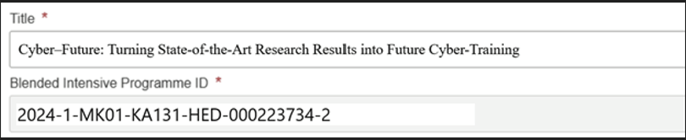

It is necessary that you insert the mobilities in the Beneficiary module so that we can have them registered in our University's profile in order to be valid.

Regarding the accommodation, our offer is:
Hotel Tim’s Apartments
https://tims.com.mk/
google.com/maps/dir//''/data=!4m7!4m6!1m1!4e2!1m2!1m1!1s0x1354144da5b89a85:0x1740ca7da33847dc!3e0?g_mp=CiVnb29nbGUubWFwcy5wbGFjZXMudjEuUGxhY2VzLkdldFBsYWNlEAEYASAB
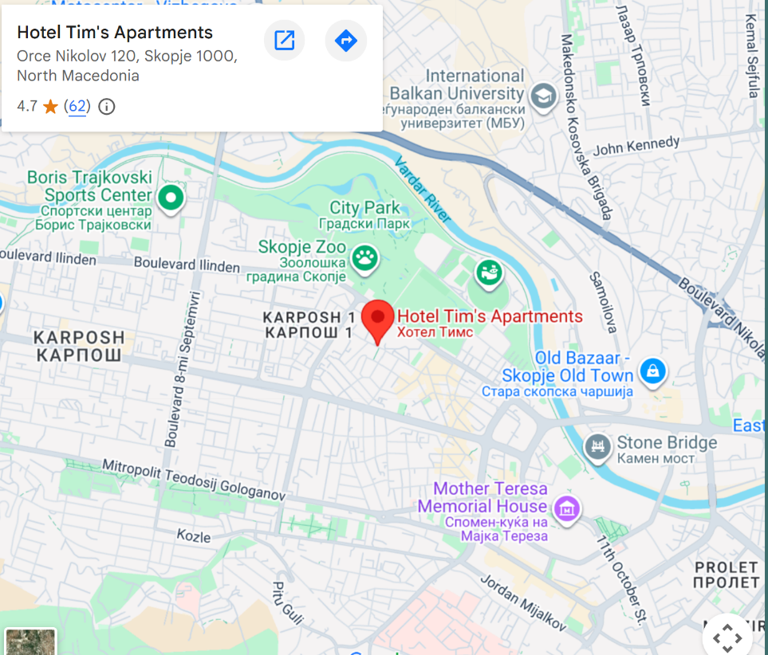

Hotel Karpos
https://www.booking.com/searchresults.html?aid=356980&label=gog235jc-10CAsokwFCEHRpbS1zLWFwYXJ0bWVudHNIM1gDaJMBiAEBmAEzuAEXyAEM2AED6AEB-AEBiAIBqAIBuAKyxpLNBsACAdICJDE0ZDM3NzRlLTVhZWItNGJlMS1iNWJhLTk3YTBiNDU5Njk2N9gCAeACAQ-Share-gVTnFVO%401772398466&no_rooms=1&highlighted_hotels=309079&checkin=2026-07-25&redirected=1&city=-95841&hlrd=user_sh&group_adults=1&source=hotel&group_children=0&checkout=2026-07-26&keep_landing=1&sid=17c6486b5e24a643255d0dbdda017677
https://www.google.com/maps/place/hotel+karpos/data=!4m2!3m1!1s0x13541443c5eb241d:0x60bb51c6ba2b7edc?sa=X&ved=1t:242&ictx=111
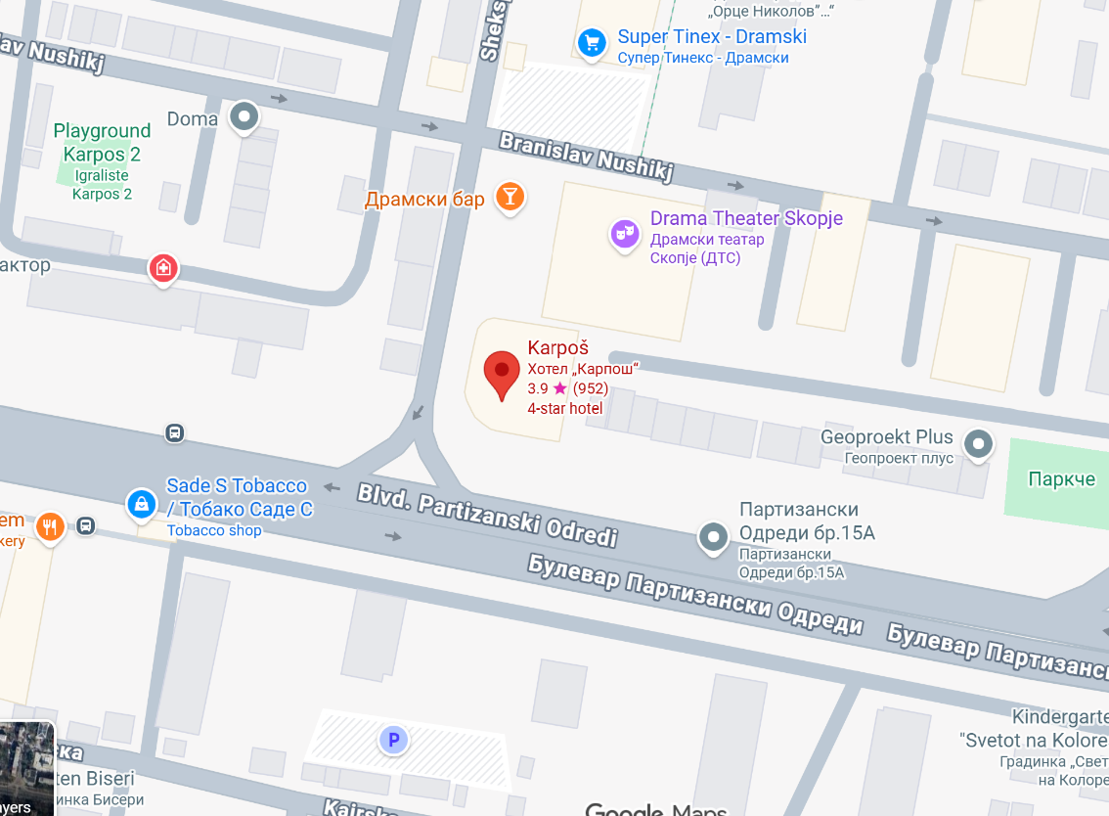

City Park Hotel
https://www.booking.com/searchresults.html?aid=356980&label=gog235jc-10CAsokwFCEHRpbS1zLWFwYXJ0bWVudHNIM1gDaJMBiAEBmAEzuAEXyAEM2AED6AEB-AEBiAIBqAIBuAKyxpLNBsACAdICJDE0ZDM3NzRlLTVhZWItNGJlMS1iNWJhLTk3YTBiNDU5Njk2N9gCAeACAQ-Share-l48wuN%401772398152&no_rooms=1&highlighted_hotels=280447&checkin=2026-07-25&redirected=1&city=-95841&hlrd=user_sh&group_adults=1&source=hotel&group_children=0&checkout=2026-07-26&keep_landing=1&sid=17c6486b5e24a643255d0dbdda017677

Being at your disposal for any further information needed,

Regards,
Adrijana Aleksikj
Junior Associate for International Projects
bip.finki@finki.ukim.mk

